**Starbucks Data set Insights:**

**Introduction:**

The 'Total Carbohydrates (g)' column provides the total carbohydrate content, including sugars, which is particularly useful for people managing diabetes or following a low-carb diet. Lastly, the 'Cholesterol (mg)' column lists the amount of cholesterol in each beverage, a critical factor for those monitThis dataset contains the nutrition info for Starbucks menu items.

The 'Beverage_category' column classifies the type of beverage, such as coffee, tea, or smoothie. The 'Beverage' column provides the specific name of the drink, for instance, Caramel Macchiato or Green Tea Latte.

The 'Beverage_prep' column details the preparation method of the beverage, including whether it's served hot or cold, and any additional ingredients or toppings like whipped cream or syrup. The 'Calories' column lists the total caloric content of each beverage, providing insight into the energy provided by each drink.

The next three columns, 'Total Fat (g)', 'Trans Fat (g)', and 'Saturated Fat (g)', provide a breakdown of the fat content in each beverage. These columns are crucial for those monitoring their fat intake for health or dietary reasons. The 'Sodium (mg)' column indicates the amount of sodium in each beverage, which is essential information for individuals on low-sodium diets.

This dataset serves as a comprehensive guide to the nutritional content of Starbucks beverages, making it a valuable resource for researchers, dietitians, and health-conscious consumers.

**Step 1:** import pandas as pd

star=pd.read_excel("star.xlsx")

Star

**Step 2:** star.head()

This method is used to display the first few rows of the DataFrame.

**Step 3:** star.tail()

This method is used to display the lastt few rows of the DataFrame.

**Step 4:** star.info()

This method is used to display the information of the DataFrame.

**Step 5:** star.columns

This method is used to display the columns of the DataFrame.

**Step 6:** Data visualization with plots

**Step 7:** import matplotlib.pyplot as plt

import seaborn as sns

star['Beverage_category'].value_counts().plot(kind='bar')

plt.show()

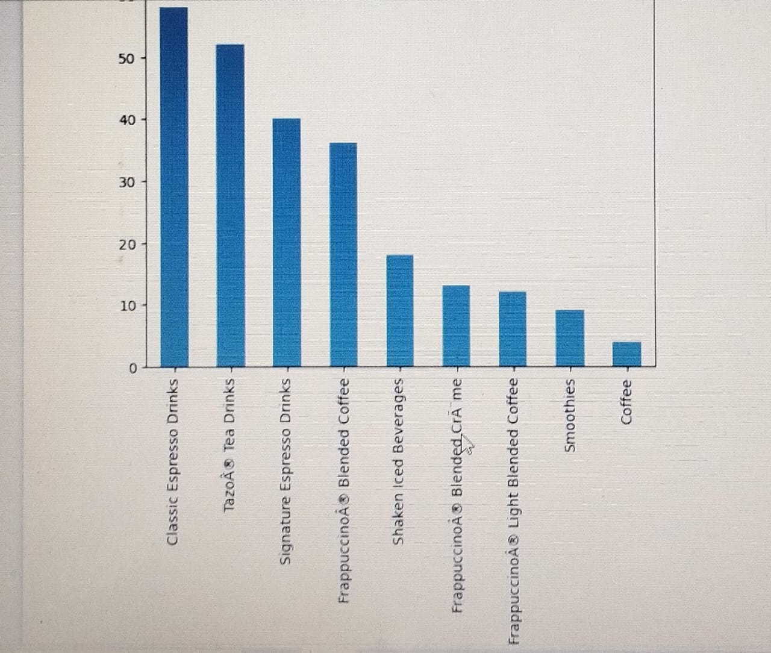

This is a horizontal bar chart showing the number of different types of drinks at a coffee shop.

Here's what the graph represents:

-X-axis: This represents the number of drinks in each category.

-Y-axis: This lists the different drink categories.

-Drink categories and their approximate counts:

Classic Espresso Drinks: 55

Tazo Tea Drinks: 50

Signature Espresso Drinks: 40

Frappuccino Blended Coffee: 35

Shaken Iced Beverages: 20

Frappuccino Blended Crème: 15

Frappuccino Light Blended Coffee: 15

Smoothies: 10

Coffee: 5

In summary, this graph provides a visual representation of the variety and quantity of drinks available at this coffee shop.

**Step 8:**plt.title('Beverage catergories count')

sns.countplot(data=star, y='Beverage_category')

plt.show()

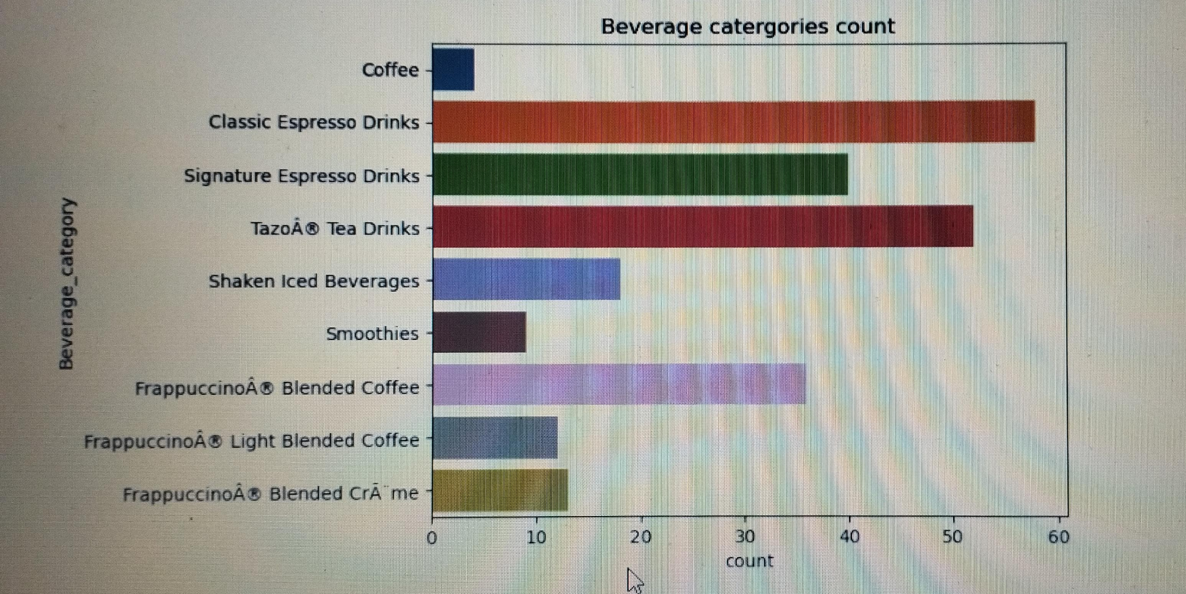

This is a horizontal bar chart showing the distribution of beverage categories.

Here's what the graph shows:

-X-axis: This axis represents the count of each beverage category.

-Y-axis: This axis lists the various beverage categories available.

The categories, listed from highest to lowest count, are:

Coffee

Classic Espresso Drinks

Signature Espresso Drinks

Tazo® Tea Drinks

Shaken Iced Beverages

Smoothies

Frappuccino® Blended Coffee

Frappuccino® Light Blended Coffee

Frappuccino® Blended Crème

In summary,the graph visually represents the popularity of different beverage categories, with "Coffee" being the most popular and "Frappuccino® Blended Crème" being the least.

**Step 9:**plt.title('Beverage Preparation')

sns.countplot(data=star, y='Beverage_prep')

plt.show()

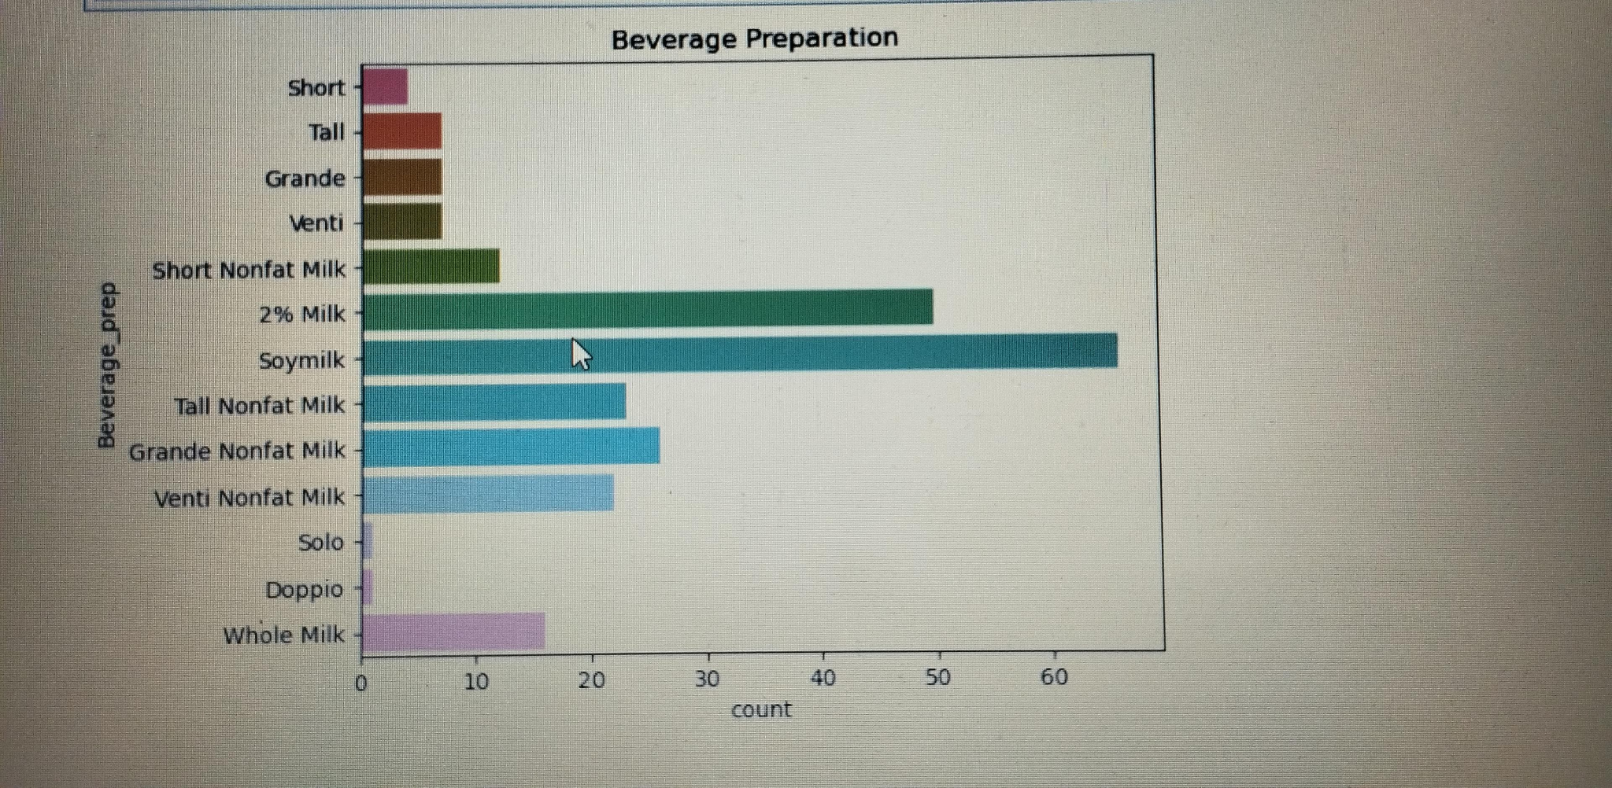

This is a horizontal bar chart illustrating the frequency distribution of different beverage preparations.

Here's how to interpret it:

-X-axis: This axis represents the different types of beverage preparations. These include various combinations of size (Short, Tall, Grande, Venti), milk type (Nonfat, 2%, Soy, Whole), and espresso shots (Solo, Doppio).

-Y-axis: This axis represents the count or frequency of each beverage preparation.

Bars: Each horizontal bar represents a specific beverage preparation, and its length corresponds to how often it appears in the dataset.

Example:

The bar representing "Tall 2% Milk" extends beyond the 60 mark on the y-axis, indicating this is the most frequently ordered beverage preparation in the dataset.

Overall, this graph allows for quick comparison of the popularity of different beverage preparations.

**Step 10:**plt.title('Beverages count')

sns.countplot(data=star, y='Beverage')

plt.show()

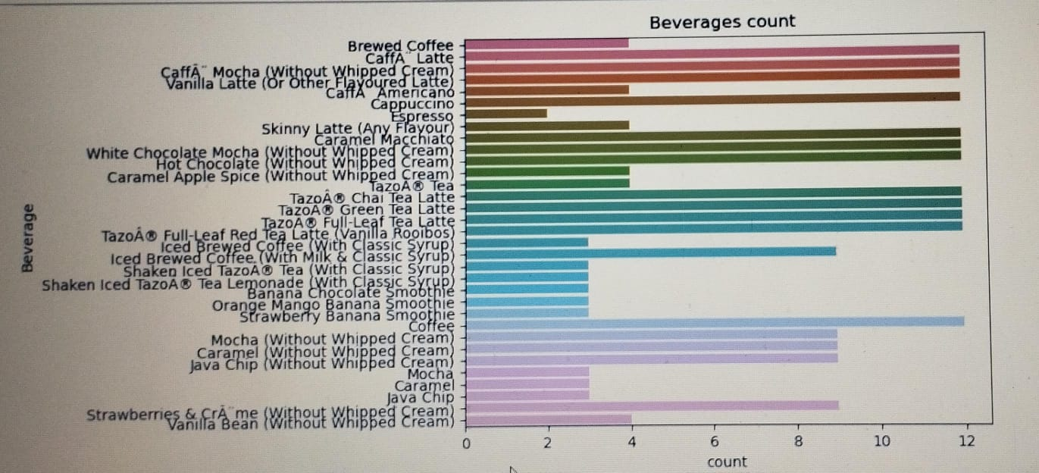

This graph presents a horizontal bar chart, visualizing the frequency of different beverages.

Here's how to interpret it:

-X-axis: This axis represents the count or frequency of each beverage.

-Y-axis: This axis lists the different types of beverages available.

Bars: Each horizontal bar corresponds to a specific beverage, and its length indicates how often that beverage appears in the dataset.

Key insights from the graph:

The most popular beverage is "Brewed Coffee."

The least popular beverages are "Strawberry & Crème Frappuccino (Without Whipped Cream)" and "Vanilla Bean Frappuccino (Without Whipped Cream)."

The graph provides a quick and easy way to compare the popularity of various beverages.

**Step 11:** scatterplot = sns.scatterplot(data=star, x=' Total Carbohydrates (g) ', y=' Sugars (g)', hue='Beverage_category')

scatterplot.legend(loc='center left', bbox_to_anchor=(1, 0.5), title="Beverage Category")

plt.show()

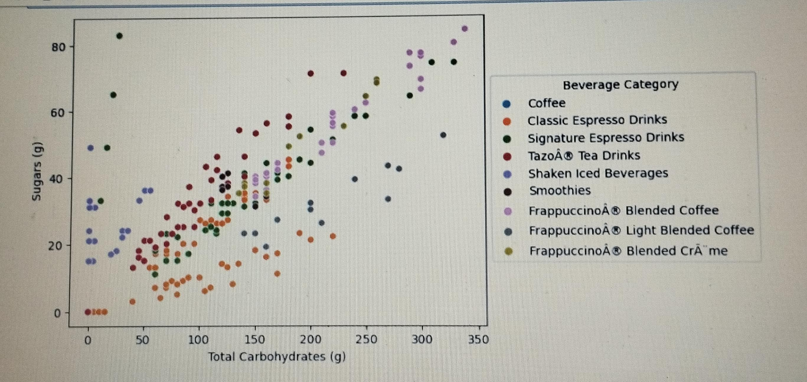

This is a scatterplot showing the relationship between the amount of sugar (in grams) and total carbohydrates (in grams) in various Starbucks beverages.

Here's how to interpret it:

Each dot: represents a different beverage on the Starbucks menu.

-The x-axis: represents the total carbohydrates in grams.

-The y-axis: represents the amount of sugar in grams.

The colour of the dot: represents the beverage category (e.g., coffee, Frappuccino, smoothies).

What does the graph tell us?

There is a positive correlation between sugar and total carbohydrates. This means that as the total carbohydrates increase, the sugar content also tends to increase.

Frappuccinos: generally have higher amounts of sugar and total carbohydrates compared to other beverage categories.

Coffee: generally has the lowest amounts of both sugar and total carbohydrates.

There is variation within each beverage category. For example, not all Frappuccinos have the same amount of sugar and total carbohydrates.

Overall, this graph provides a visual representation of the nutritional content of different Starbucks beverages.

**Step 12:**import plotly.express as pt

pt.histogram(star,x='Cholesterol (mg)',nbins=25,title='Histogram Plotly')

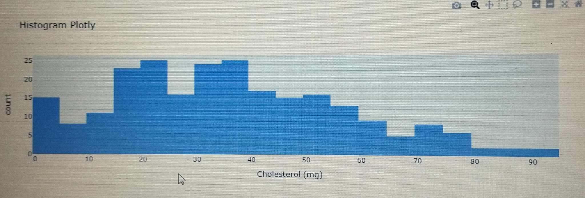

This is a histogram, a graphical representation of the distribution of a dataset.

Here's how to interpret it:

-X-axis:

This axis represents the variable being measured, which in this case is "Cholesterol (mg/dL)". It's divided into bins, or ranges, of cholesterol levels.

-Y-axis:

This axis represents the frequency, or count, of observations within each bin. In simpler terms, it shows how many people fall into each cholesterol level range.

Bars:

The height of each bar represents the number of data points that fall within that specific bin.

Overall, the graph shows the distribution of cholesterol levels within a group of people. You can observe things like:

The most common cholesterol range (the tallest bar)

How spread out the data is (how wide the distribution is)

Whether the distribution is symmetrical or skewed

Any outliers or unusual observations (data points that are far away from the majority)

To fully understand the graph, you would need additional information, such as:

The sample size (number of people included)

The range of cholesterol levels considered healthy vs. unhealthy

The purpose of the study or data collection

**Step 13:**star.boxplot(column=[' Sugars (g)'])

plt.show()

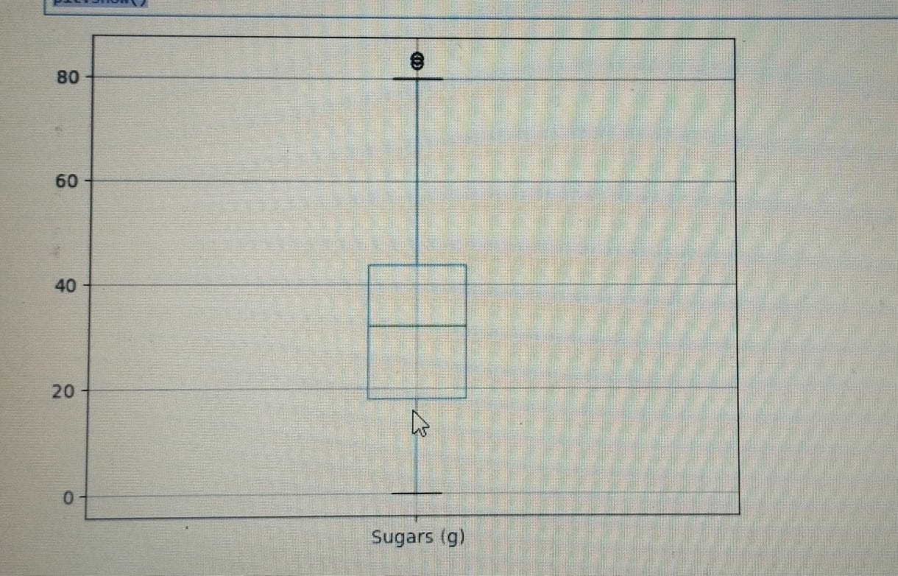

This box plot shows that:

The median amount of sugar is around 40g.

The middle 50% of the data falls between roughly 30g and 50g.

There is one outlier with a very high sugar content compared to the rest of the data.

**Step 14:**fig = px.scatter_3d(star, x=' Total Carbohydrates (g) ', y=' Protein (g) ', z='Beverage_category',

color='Beverage_category', template = 'plotly_dark', title = 'Beverages for athletes')

fig.show()

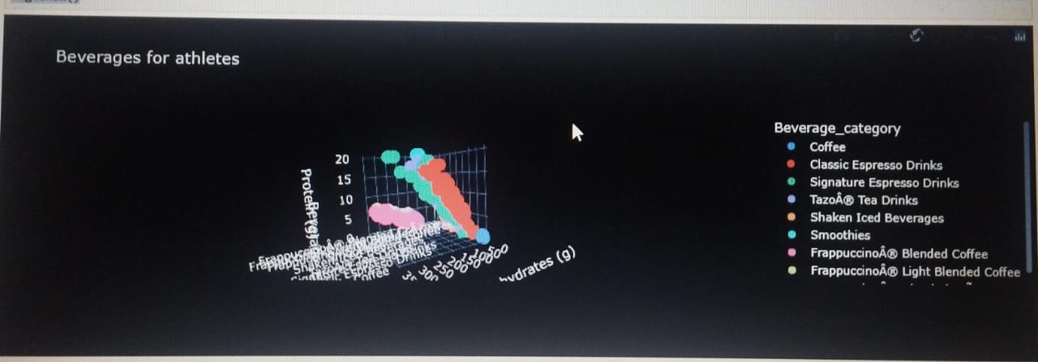

This image displays a 3D scatter plot visualizing data on beverages for athletes.

Axes:

-X-axis: Likely represents the caffeine content in the beverages.

-Y-axis: Shows the protein content in grams (g).

-Z-axis: Represents different beverage categories, although the specific categories are not fully visible in this image.

This visualization helps compare various beverages based on their caffeine and protein content while categorizing them, allowing athletes to make informed choices.

**Step 15:**dietary_fib = star.groupby('Beverage_category')[[' Dietary Fibre (g)']]

plt.xticks(rotation=45, ha='right')

sns.boxplot(data=star, x='Beverage_category', y=' Dietary Fibre (g)')

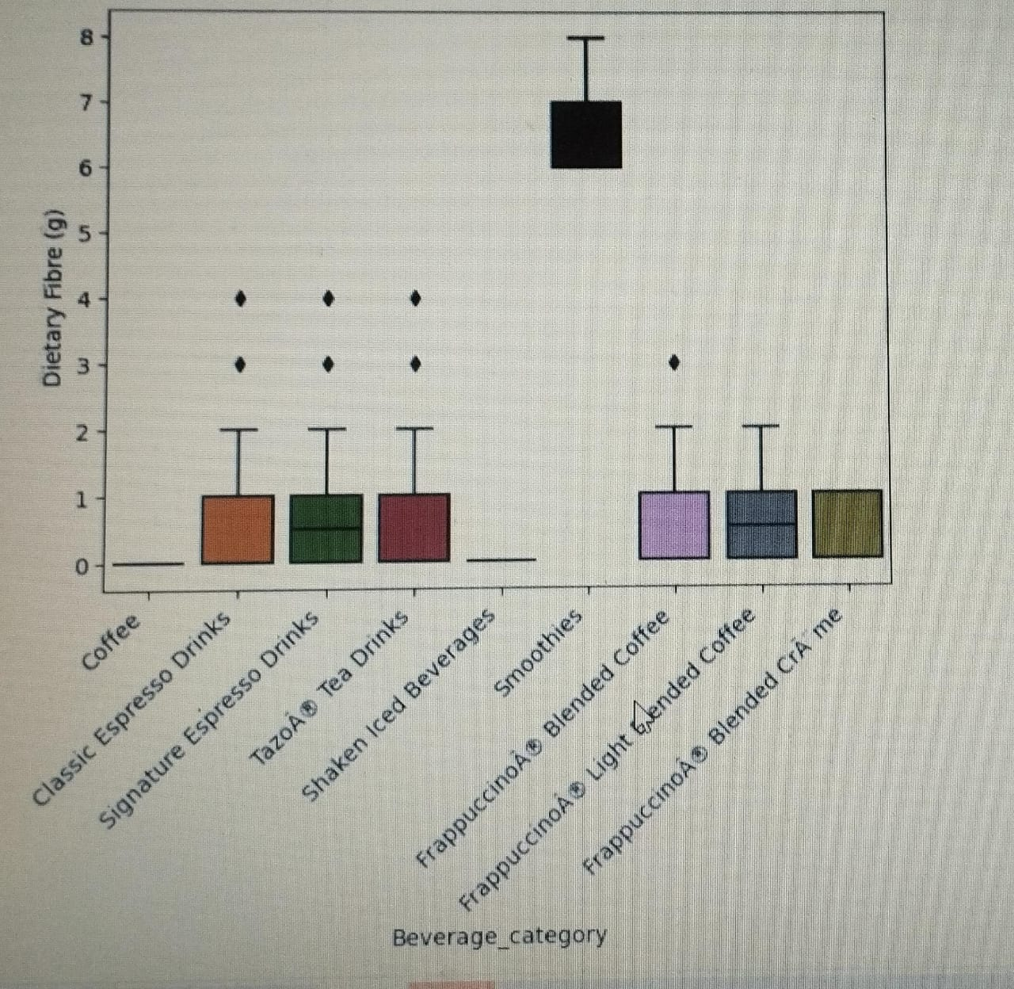

Overall, this diagram allows for easy comparison of dietary fiber content across different beverage categories at Starbucks

The "Smoothies" category has a higher median dietary fiber content compared to the "Classic Espresso Drinks" category.

The "Frappuccino® Blended Coffee" category has a large spread of data, indicating a wide variation in dietary fiber content among different beverages in that category.

There are a few outliers in the "Shaken Iced Beverages" category, showing that some beverages have significantly higher fiber content than others in that category.

**Step 16:**fig = px.pie(star, names = 'Beverage_category', values='Caffeine (mg)', title='Caffeine distribution by beverage category')

fig.show()

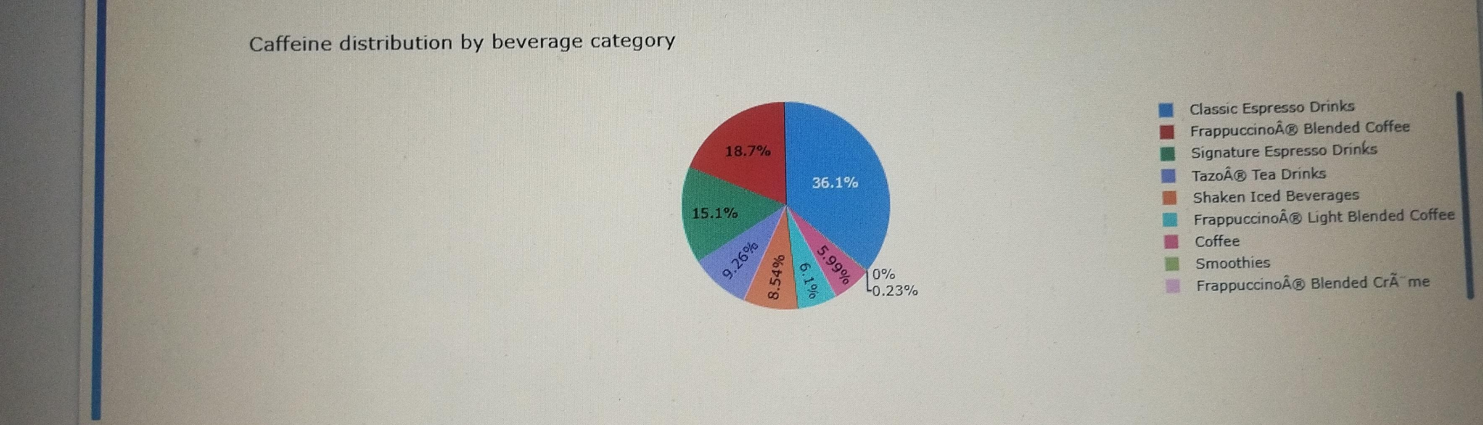

This pie chart illustrates the distribution of caffeine across various beverage categories.

The chart reveals that Classic Espresso Drinks contain the highest amount of caffeine, followed by Frappuccino Blended Coffee and Blended Coffee.

**Conclusion:**

Starbucks has several beverage categories. The nutritional content of each of these beverages is different. It will be quite difficult to choose the one that suits us by looking at the individual ingredients of each beverage, but if we have a visualization of this data, our job will be easier. For example, if we are on a low-calorie diet, we choose regular coffee, while if we are trying to gain weight, we choose signature espresso drinks, which contain high protein and carbohydrates. If we suffer from high cholesterol disease, we know that we should not choose Frappuccino Blended Coffee by looking at this visual data. This is the power of visualized data!